# **CTF Topic: Web Site enumeration**

# **Introduction**

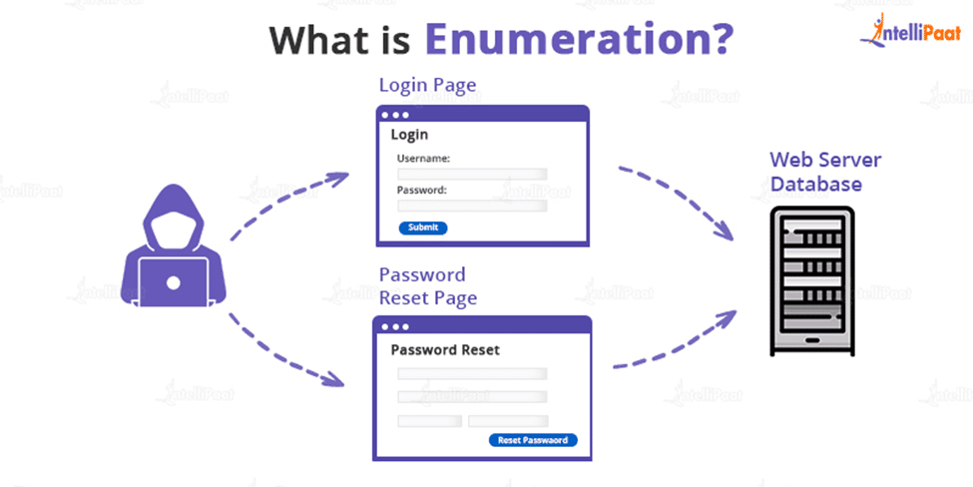

Website enumeration is crucial in the information-gathering phase of a web security assessment or a Capture The Flag (CTF) competition. The goal is to gather as much information as possible about a target website, including Domain, subdomains, Server used, and more. This information can then be used to identify potential vulnerabilities and plan further attacks.

# **Tools and requirements**

* [synapsint](http://synapsint.com)

# **Link**

Target: [www.blanxer.com](http://www.blanxer.com)

# **Scenario**



You are participating in a CTF competition, and the first challenge is to enumerate information about the target website **www.blanxer.com.** You need to gather as much information as possible

# **Process to Perform**

* First Go to the [Website](http://synapsint.com)
* Then, sca for the target which is given in link

# **Let's Begin The Challenge**

# **Question**

Flag 1: What is the Organization name of the blanxer website ?

Answer: Vercel, Inc.

Flag 2: What is the Internet Service Provider of Blanxer(ISP)?

Answer: Amazon

Flag3: What is the full form of RDAP?

Answer: Registration Data Access Protocol

Flag 4: What is the IP of Comfortware.blanxer.com subdomain site ?

Answer: 104.21.67.254

# **Hint**

